TDS-536 TV Dipole Set Data

More Information
- Typical Antenna Factor Plot - 3m
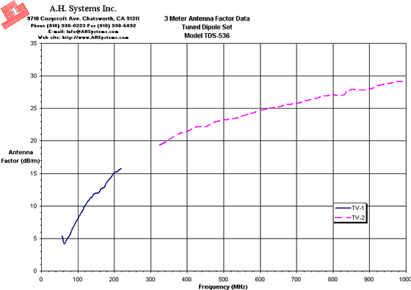
Innovation, Quality, and Performance
- Typical Antenna Factor Plot - 10m
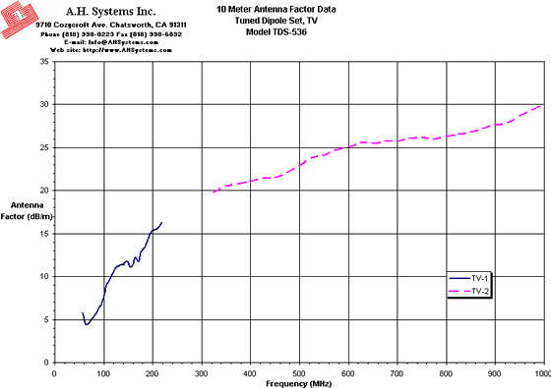
Innovation, Quality, and Performance
- Typical VSWR
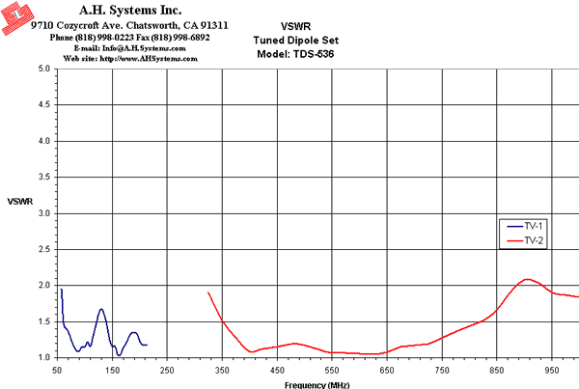
Innovation, Quality, and Performance
- Operation Manual (180Kb)

