Dontyne系统产品线

Dontyne产品线提供了齿轮生产过程各个阶段数据管理的软件和硬件产品。这些产品包括了下列领域：product line offers software and hardware in keeping with the company philosophy to permit constant managed data at all stages of the gear production process. These products cover the following areas:
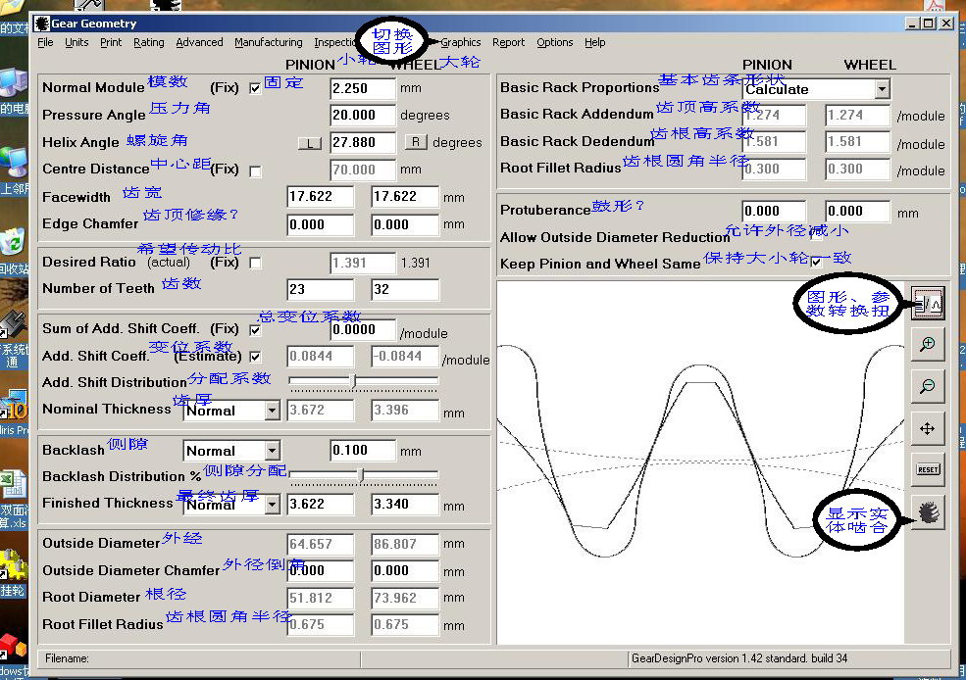
齿轮设计和等级管理软件
系统建模
加工
检查
Dontyne可以在齿轮生产过程的其它领域提供支持和服务:
- Small Scale Design Projects小齿数设计方案
- Large Scale Design Projects大齿数设计方案
- Prototyping原型
- Testing测试
The scope is ever increasing to include yet more CAD systems, metrology equipment and machine tools used within the industry. The greater scope enables the application of the software to ever more projects, and in some cases the integration of a complete data management system within the production process. Keep up to date with improvements to current software and services by registering your e-mail details.

Small Scale Design Projects
Gear Design Optimisation
The experience and expertise within Dontyne can be applied to your own gearing problems. Assistance as available whether defining or improving either gear design, manufacturing and inspection operations.
Consultancy
Dontyne staff can be utilised to enhance your project resources either remotly or on-site.
Teaching and Training
We can offer training on our own products or short courses on gear design techniques.
Use our enquiries form to contact us outlining your particular needs.

Large Scale Design Projects

Aspects of gear production are outside of the current scope of in-house capabilities. Donytne works with external partners to extend the assistance beyond the design and analysis stage and offer an integrated project solution.

The Design Unit is a self funding organisation based within the University of Newcastle, England. It has over 35 years experience of designing, developing and testing in the mechanical power transmission sector. The unit has 12 Research Engineers, 3 Research Associates, 9 Technical and Support Staff.
Design Unit staff have special expertise in the following technologies:
- Gear, belt and chain drive design and stress analysis
- Gearbox and transmission system design
- Gear noise and vibration measurement and analysis
- Drive system dynamics, experimental and theoretical analysis
- Special measurement and data analysis systems for mechanical drives
- Gear surface and bending fatigue strength
- Gear and steel heat treatment and metallurgy
- Gear manufacture and gear metrology
There is also a multi-disciplinary research program covering most aspects of gearing. This wealth of expertise allows application to various areas within the gear industry...
Large Scale Design Projects

Metrology and Inspection
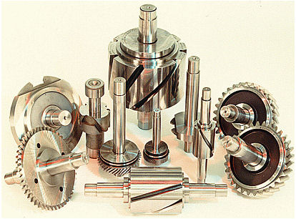
Prototyping Capability
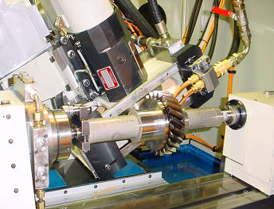
Testing Facilities
Materials Testing
- Barkhausen Noise
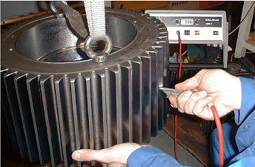
- X-Ray Diffraction
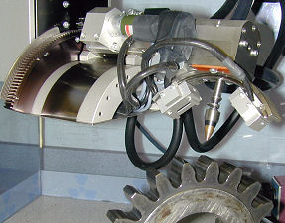
Properties Testing
The re-circulating test-rigs can also be purchased as a product in their entirety.
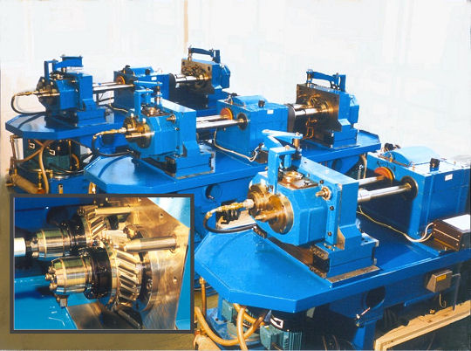
The re-circulating test-rigs can also be purchased as a product in their entirety.
If you would like a more comprehensive overview about products and services or potential collaboration click here.

Prototyping
Testing Facilities
Materials Testing
- Barkhausen Noise
- X-Ray Diffraction
Properties Testing
The re-circulating test-rigs can also be purchased as a product in their entirety.
Gear Production Suite

Gear Production Suite
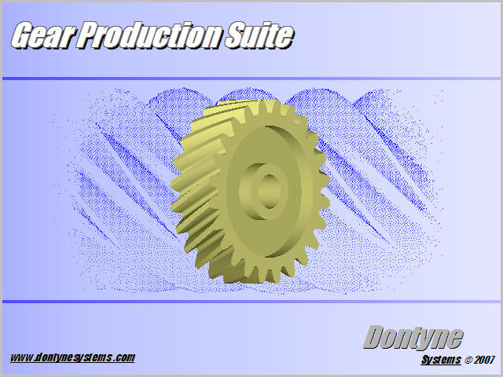
A suite of programs to design, machine, and inspect gears during production. Each program module has been developed with three levels of operation (basic/standard/advanced) to better suit your requirements. An integrated application of these modules can be used to optimise the conception design, production, and operation of gears by the centralisation of the data within a company and creating a feed-back loop.
The functionality of one or more tools within the suite can be formatted as stand-alone so as to be embedded in existing metrology or machine tool equipment to form part of an expert system.
Click to install demo version ****NOTE: The program may be blocked by your virus checker. Consult your IT professional if program does not run****
Tutorials are available to assist in your evaluation of the program
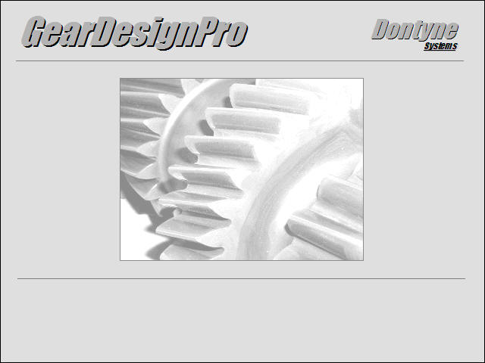
Gear Design Pro - Gear Design and Rating
This program allows the definition of gear pair geometry and a calculation of their rating according to ISO Standards. Recent changes to ISO6336 in 2006 have been implemented, as well as the supplement in 2007. A 72 page validation document consistent with the examples in the installation will be provided with the purchase of the advanced level of this module.
Variants
Spur and helical gear according to ISO6336 with tolerances according to ISO1328.
Description of Functionality
Basic Operating Features
- Involute gear geometry for spur and helical gears
- Standard tooth proportions or calculate for maximum contact ratio
- Plots of gears in 2D and 3D
- DXF output of transverse tooth profile
- Co-ordinates of transverse tooth profile
- Flank tolerances to ISO 1328 part 1 (1995)
- Radial composite tolerances to ISO 1328 part 2 (1997)
- Measurement over balls and base tangent chordal span including contact height
- Metric or English units
- Gear rating to ISO 6336 (2006)
- Gear sizing
- Flash temperature calculations based on AGMA 2101-C95
- Graphical plot of specific sliding
Standard Operating Features
Includes all basic operating features plus:
- Protuberance
- Data entry on main form using ↑ ↓ keys
Advanced Operating Features
Includes all basic and standard operating features plus:
- Centre distance minimization
- Design workspace search for optimisation (approx 10,000 designs)
Optimal - Gear Tool Optimisation
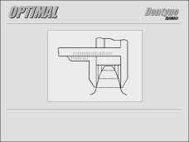
The aim of this software is to provide a set of tools to optimise the generation of gear forms in various production techniques. The technique can be applied to arbitrary gear forms whether nominal, segmented, asymmetric, or even non-circular. The program utilises various interfaces to CAD systems, metrology equipment (dedicated gear metrology machines, touch sensor CMM, optic sensor CMM), and machine tools. The software calculates inherent errors from the machining process by comparing measured results to those generated by CAD sources (ASCII, VDA, and DXF format files). The error measurements can be evaluated according to recognised metrology standards. Proposals for improvement to the tooling and machining procedure can be made to enable efficient ‘closed loop’ manufacturing procedure.
Variants
Form Gearing (injection moulding, sintering, forging, extrusion)
Description of Functionality
Basic Operating Features
- Generation of Gear Geometry
- Compatablity with other CAE Gear Design formats
- Compatablity with other CAD, CMM and Gear Checking equipment
- Profile Editing (Cut/Insert Points, Lines and Curves)
- Tool Definition
- Inspection (DIN/ISO) (Profile, Flank Line, Pitch,...)
- CMM Simulation (Theoretical/Measured Contour Comparison)
- Error Mapping Calculation
- Correcting Action on Tooling
Standard Operating Features
- Automated features; tip and root rounding
- Filtering of Error (Weighting, Trends, Averaging, Statistical Analysis)
- Curve Fitting ('Best Fit')
- Definition of Iterative Optimisation Process
Advanced Operating Features
- 3D Surface Inspection
- Single/Double Flank Inspection Simulation
- 3D Surface Correction
- Machine simulation to improve Diagnostics (Wire Erosion)
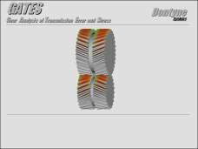
GATES is a software program for the calculation of stress and transmission error conditions in loaded gear systems. Derived from DU-GATES 3D FE package from the Design Unit, Newcastle Upon Tyne, the program has undergone an extensive validation process on test gear sets. Already implemented by some of the most trusted gear design and manufacturing institutions in the UK, the program has been used in the development of an extensive range of marine, industrial and automotive applications. Versatile graphics and reporting features offer a quick interpretation of the resulting analysis and formatting for customer reports. Links to metrology and manufacturing equipment enable evaluation of existing gear components as well as newly designed components.
Variants
Spur, helical, double helical gears
Characteristics
The analysis of gear pairs under load.
Description of Functionality
Basic Operating Features
- Surface Definition (Profile/Flank Correction)
- 'Thin Strip' Analysis
Standard Operating Features
- N/A
Advanced Operating Features
- Full 3D FE Analysis
- Definition of Shaft and Bearing Conditions
System Requirements
- 500MHz plus PC
- 128MB RAM
- Fixed hard disk with 50MB free diskspace
- CD ROM drive
- Windows 2000 onwards
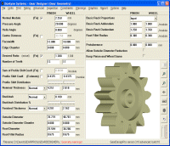
GearDesignPro
GearDesignPro is a new user friendly program for spur and helical gears. It has several modes of operation where a geometry manager automatically adjusts the gear design to the specified centre distance or calculates the centre distance for a given geometry.
Features include:-
- ISO 6336 gear rating for contact and bending strength
- Flash temperature calculations
- Centre distance optimization
- Design workspace search
- ISO 1328 gear tolerances
- Measurement over balls and chordal span
- Partial DXF output
Initial Sizing
Modes of Operation
Design Workspace Search
Measurement over Balls
Gear Rating
Tolerancing
Centre Distance Optimization
Initial Sizing
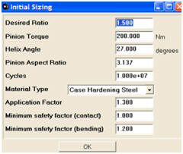
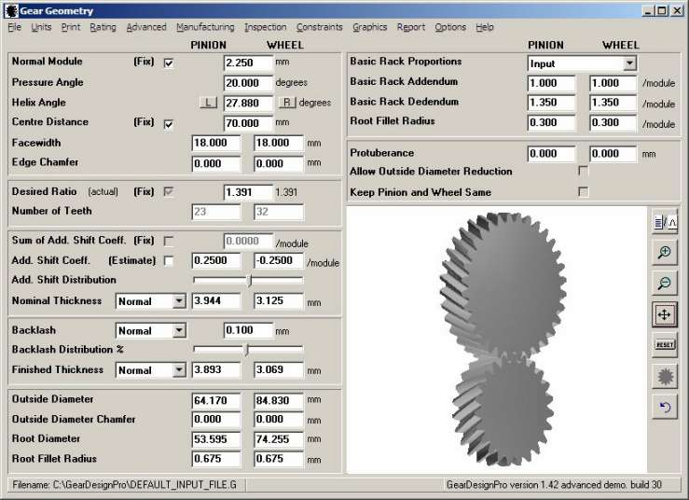

Various graphical displays of gear teeth that automatically update following changes to geometry
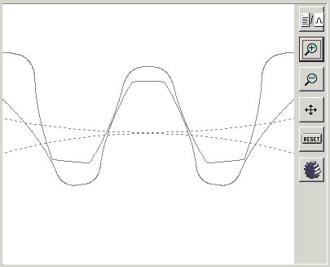
The effects of protuberance and tooth thinning can be observed
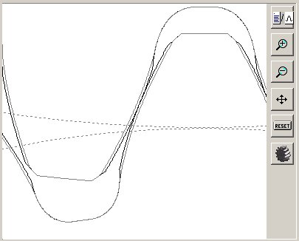
The report window can display graphics, geometry or rating calculations
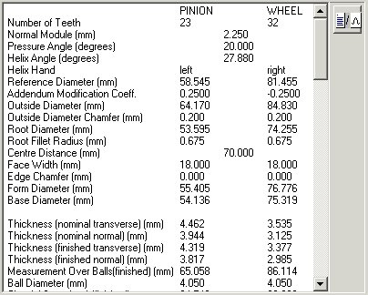
The initial centre distance can be approximated for the torque, type of material and duration.
The centre distance optimisation option can then be subsequently used to adjust the value of centre distance for the chosen details of the gear set.
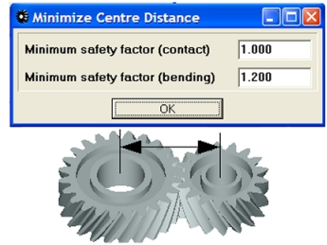
Modes of Operation
GearDesignPro includes a geometry manager that operates in several modes.
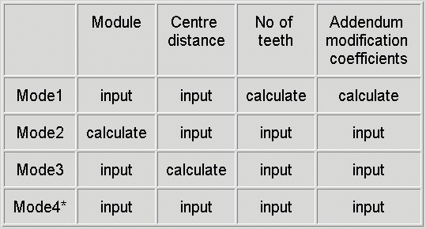
* Mode 4 is a special mode in which the geometry manager is overridden. Valid gear geometry must be entered.
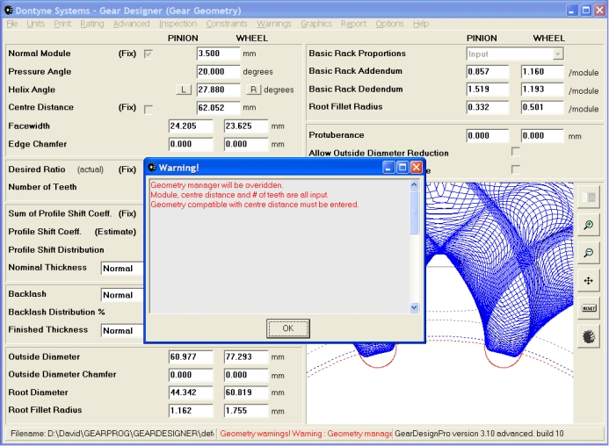
Design Workspace Search
Over 8000 gear designs can be created and analysed in minutes.
Various parameters can be plotted against each other enabling the designer to select the optimum design for their requirements.
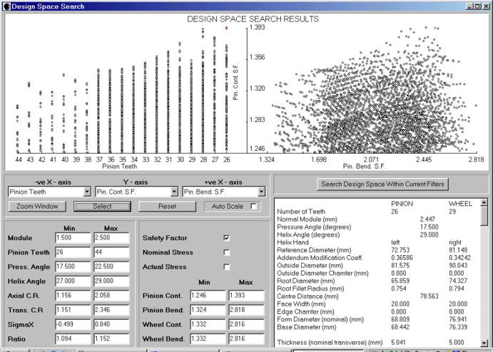

Measurement over Balls
Tooth thickness can be specified by measurement over balls or chordal span.
Contact height for ball is provided to determine whether ball size is suitable.
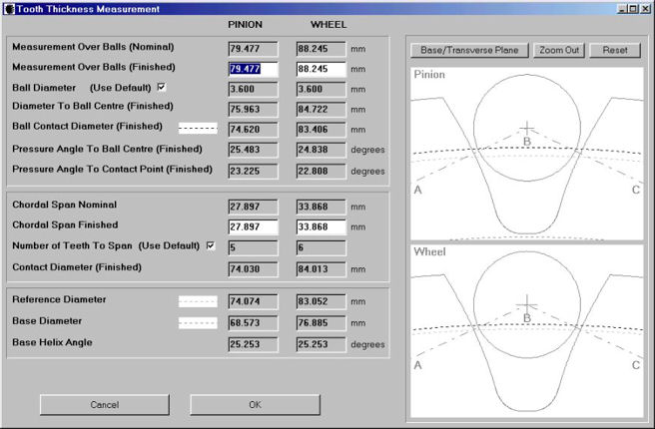
Gear Rating
Gear rating is based on ISO 6336.
A validation example is provided with the software that has been correlated with hand calculations.
Rating results can be summarised in mainform report. This immediately updates upon changing gear geometry.
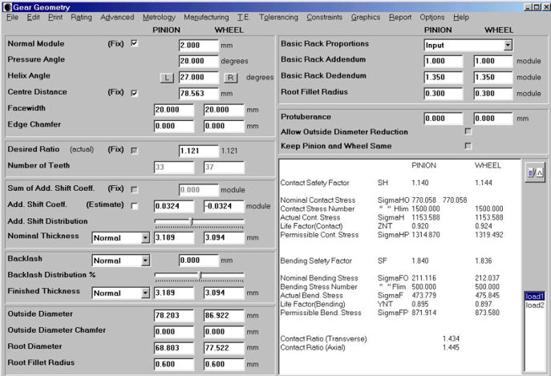
Alternatively factors and intermediate date are provided in a more in-depth report.
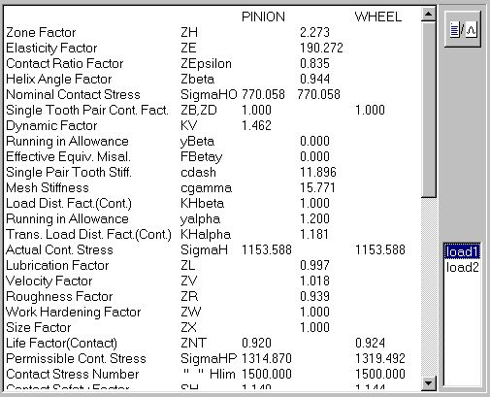
The material properties and fatigue data can be edited.
Multiple loadcases can be applied to the gear design.
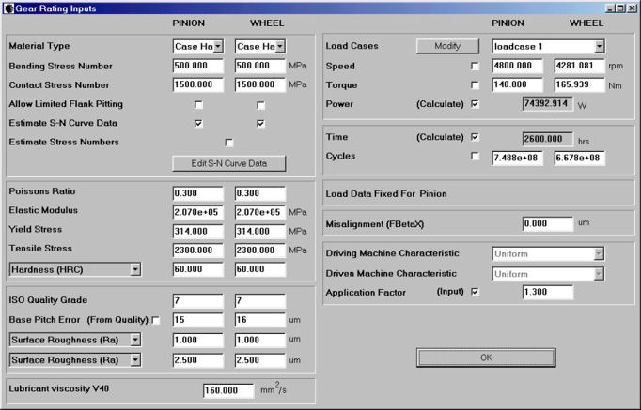
Tolerancing
Gear tolerances are automatically calculated based on the standard ISO 1328.
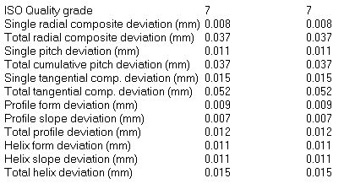
Centre Distance Optimization
The centre distance can be optimized under the current helix angle, material properties and geometry constraints in order to minimise it.
The resulting centre distance will be the minimum where all safety factors are above 1.0.
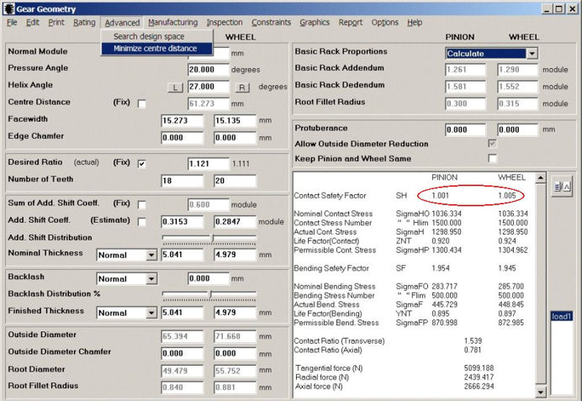


Inspection Software
Gear inspection software from Dontyne Systems.
The program includes interfacing to other systems and so can read theoretical design data and measurement files from various different CAD, CMM and specialised gear measuring machines.
Described here are the main analysis capabilities of the programs and the functions which can be carried out to improve inspected components.
Features Include:
Profiles (faf, faH, faF)
Flank Line (fbf, fbH, fbF)
Pitch (fp, fu, Rp, Fp, Fz/8)
Tooth Thickness (Rs)
Tooth Runout (Fr)
Measurement over Balls/Rollers (Mdk/Mrk)
Single Flank Transmission Error (fi, Fi)
Topography - Tooth Grid
Profiles (faf, faH, faF)
It is possible to carry out a typical profile analysis over a given evaluation range for individual profiles read from file or as a result of other analysis.
The profiles shown here use linear regression tolerance bands, but other tolerance forms (including user defined) are possible.
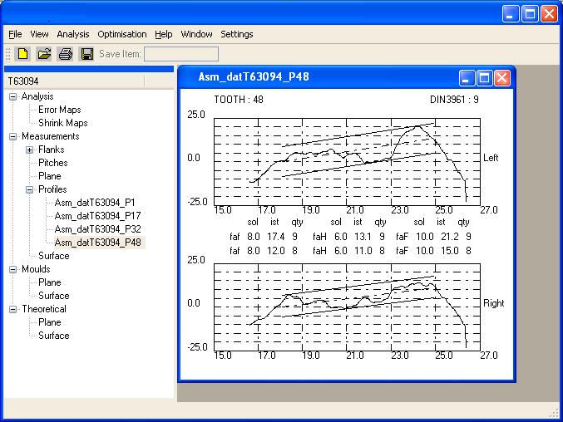
Flank Line (fbf, fbH, fbF)
It is possible to carry out a typical profile analysis over a given evaluation range for individual profiles read from file or as a result of other analysis.
The flank lines shown here use linear regression tolerance bands, but other tolerance forms (including user defined) are possible.
Pitch (fp, fu, Rp, Fp, Fz/8)
The pitch analysis shows pitch analysis for two flanks. Results can be obtained for a set of measurement data read from a file, or those derived from a surface comparison. Values for composite error, Fp, or indexing eror, fp, (also called adjacent error), tooth spacing error, fu, (also called tooth to tooth error), the range of adjacent pitch error, Rp, and the cumulative circular pitch error, Fpz/8 are calculated.
Values of thickness and run-out errors can be derived from the pitch error graphs.
This diagram is a typical pitch error plot showing both graph types. A graph of composite error or indexing error can be shown.
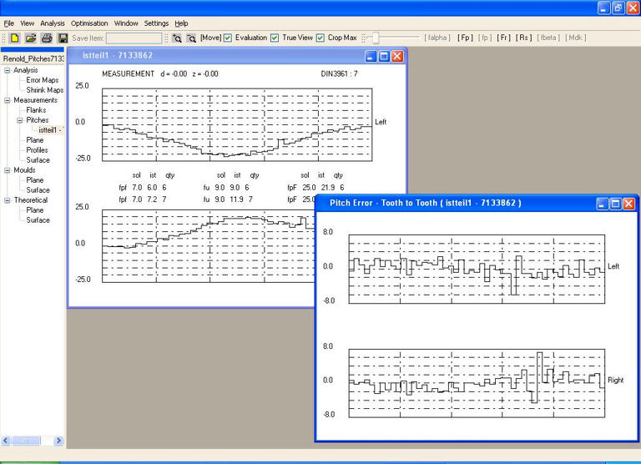
Tooth Thickness (Rs)
The tooth thickness graph can be generated from a set of pitch error data.
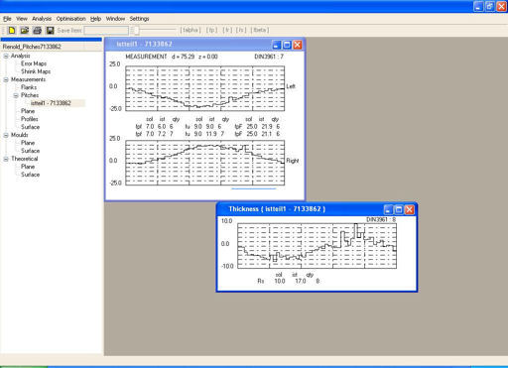
Tooth Runout (Fr)
The tooth thickness graph can either be generated from a set of pitch error data representing single flank contact testing, or derived using surface measurement data and feeding in a ball in each tooth gap simulating a double flank inspection procedure.
Measurement over Balls/Rollers (Mdk, Mrk)
The measurement over balls/rollers function has been frequently requested. It is possible to derive a value from a scanned 2D or 3S surface measurement or calculated error map. Choosing the [Mdk] button from the toolbar shows two balls located in opposing tooth gaps. The distance from the outside of these two located balls is shown in the diagram. For helical gear forms the normal tooth space is calculated for the tooth form before the iteration is carried out to establish the value. The Mrk value is calculated for segments or non-circular gears. Span over teeth (Wk) [Under Development]. This will be used to calculate the span over a given number of teeth from a marked flank and tooth number simulating a calliper measurement.
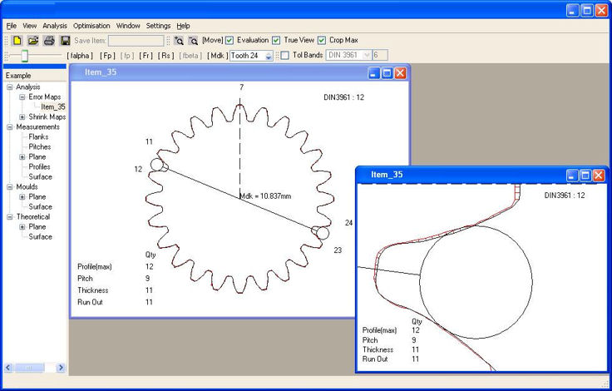
Single Flank Transmission Error
The contact conditions for a given gear measured gear tooth or a tooth calculated from a given tool and machining process can be investigated. The consequences of design or machining changes can immediately be assessed and appropriate action taken. The figure below shows the contact area (reduced from full-face in the conjugate case by tool design to allow for oil entry on running in) under no load for a worm gear tooth and the expected transmission error. The consequences of applying profile modification (linear/parabolic in this case) can be immediately assessed. Linear Parabolic.
No Profile Modification
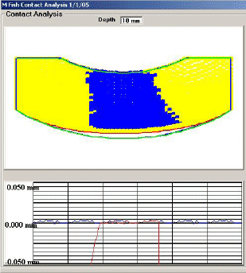
Linear Modification
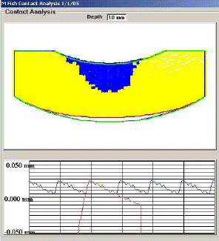
Parabolic Modification
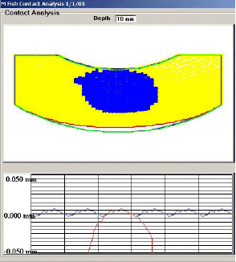
Topography - (Tooth Grid)
The tooth grid shows measurements recorded on both flanks of a single tooth displayed in a similar method to that illustrated in VDI 2607. Individual lead and profile measurements (marked red in the diagram) can be selected.
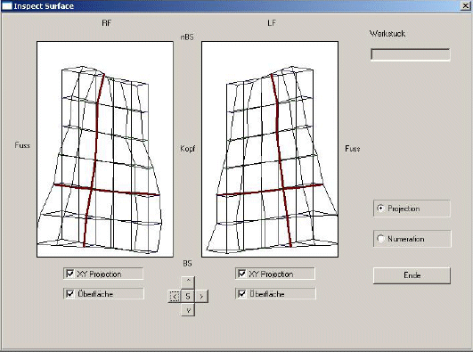

GATES
Hob Tool Optimization
This will be a new variant to the 'Optimal' program which will allow the optimization of hob tooling for helical and spur gear forms. The analysis will make use of a newly developed contact model to analyse contact conditions under no load and define corrective tool and machine setting simulating shop floor inspection techniques.

Features include:-
- A 3D FE based gear load analysis program
- Calculates the transmission error for spur, helical and double helical gears
- Calculates the contact and root bending stress
- Various graphical interfaces
- Multiple Loadcase
Load Analysis Model
This program will analyse contact conditions from defined components whether gear parts or between tool and work. It will include models of the components under load to calculate and display stress conditions. There will be varying degrees of sophistication in these models.
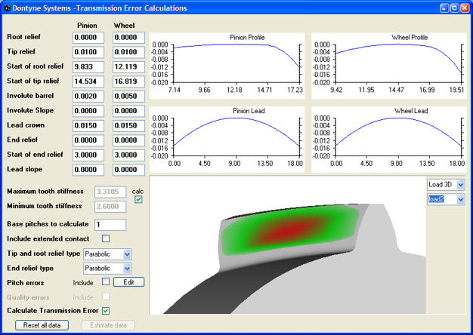
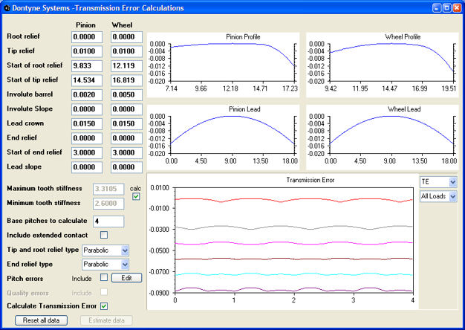
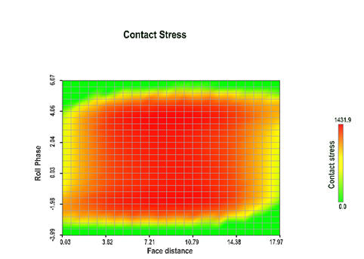
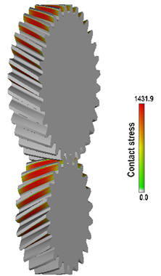
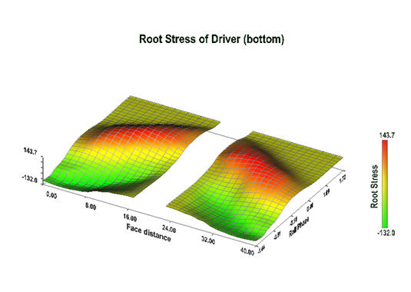
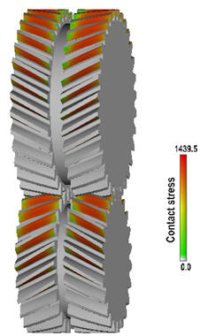
GATES Presentation

